

***Comsats University Islamabad,***

***Abbottabad Campus***

**Object Oriented Software Engineering**

**Project:**

Contextual Chatting App

**Group members:**

**Arqum Ejaz (SP21-BSE-039)**

**Arsal Bilal (SP21-BSE-040)**

**Sarmad Haseeb (SP21-BSE-023)**

**Ehsan ul Haq (SP21-BSE-013)**

**Yaseen Sajid (SP21-BSE-027)**

**Muhammad Shoaib (SP21-BSE-035)**

**Ozair Idrees (SP21-BSE-029)**

**Saifullah (SP21-BSE-022)**

**Description:**

Contextual chatting app is a platform where users can get and share opinion from people of respective field. Sometimes we have some queries regarding any field and we look for people of the respective field to solve our queries. Contextual chatting app will give us that platform.

In order to use the app the user first has to get registered with the app. After registration the user will log in to the app. The user will enter dashboard at the login from where he/she can visit profile and select the field of their interest. After selecting the field, where user chat with a group of people belonging to specific field.

The name of the group will on the name of any event being discussed in the group. The name will be the matter any user wants to discuss with people of respective field. If a person has any query, he will join the group of respective matter.

In group chat user will have an option of giving thumbs up to any message by any individual. The message having most thumbs up can be seen at the top of conversation in form of a reference.

**Use Case Modeling:**

**Diagram:**

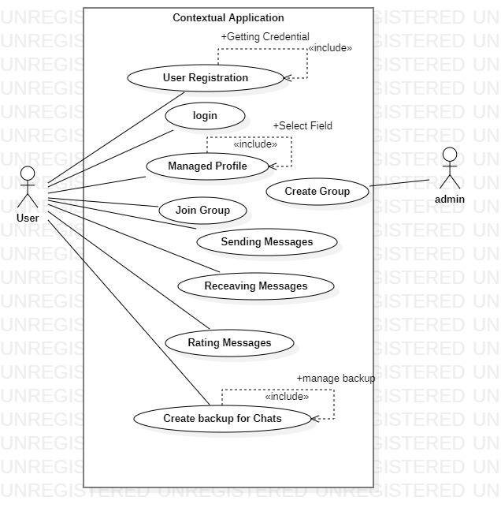

**Use cases assignment:**

|  |  |
| --- | --- |
| Use Case | Assigned Member |
| Register User |  |
| Login |  |
| Manage Profile |  |
| Create Group |  |
| Join Group |  |
| Send Message |  |
| Receive Message |  |
| Rating Message |  |
| Create backup for chats |  |

Register user Arqum

Login Arsal

Manage profile Yaseen

Create group Uzair

Join group Ehsaan

Send message saif

Receive message saif

Rating message sarmad

Create backup for chats Shoaib